Name .
Inequalities:
Read the following statements and circle the key words that indicate
the relationship of the inequality. For example, 7 is less than 10.

- 17 is fewer than 6 times a number. 17 $<$ 6x
- A number decreased by 10 is greater than 42. N-10 $>$ 42
- The sum of 4 and 2x is at most 26. 4+2x $≤$ 26
- You must be at least 16 to have a license. x $≥$ 16
- Kate is having a yard sale, and she is selling DVDs for $5 apiece. If she wants to make more than $60, how many DVDs must she sell? 5x $>$60

- Pat has $7 more than David before going out to eat. If Pat’s meal was $12.37 and David spent only $8.25, does David still have less money than Pat?
D=David’s money; P= pat’s money; Is D $<$ P ?

- When a number is divided by 2, the answer is not more than 14. $\frac{x}{2}≤14$

Continue to circle the key words of the inequality. Determine whether the following statements are true or false. If the statement is false, explain your reasoning. (HINT: use the number line to help visualize the statements.)
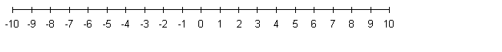1. -7 is not greater than 4 True -7 < 4
- 4 added to -9 is less than 0 True 4+(-9) < 0
- -3 plus -7 is more than 3 False; -3+-7=-10, which is not more than 3; (-3)+(-7) > 3
- 0 times 4 is greater than or equal to 0 True $0*4≥0$
- 1 is not less than 4 plus -2 False; 4+(-2)=2, and 1 is less than 2 1 > 4+(-2)

